TALENTVERSE AI: Accelerating High-Volume HR Analytics via AMD ROCm™

Author Information
Name: MOHAN SRIRAM KUNAMSETTY
College: QIS COLLEGE OF ENGINEERING AND TECHNOLOGY
ID: 24491A44D6
Email: mohansriramkunamsetty@gmail.com
GitHub Repository: https://github.com/SriRamkunamsetty/TALENTVERSE-AI.git
Date: June 2026

1. Abstract
TALENTVERSE AI is a next-generation human resources platform that utilizes advanced Natural Language Processing (NLP) to parse, rank, and match thousands of candidate resumes against complex job descriptions. Performing deep semantic similarity searches across thousands of PDF resumes simultaneously overwhelms standard CPU infrastructures, causing unacceptable latency for HR recruiters. This paper details our successful migration to the AMD ROCm ecosystem. By accelerating our NLP vector-embedding models on AMD Instinct™ MI300 clusters, we achieved a 53x reduction in document parsing latency, allowing TALENTVERSE AI to evaluate massive candidate pools in real-time.

2. Introduction
In modern enterprise recruitment, a single job posting can attract thousands of applicants. Reviewing these resumes manually is impossible, and legacy keyword scanners are ineffective. TALENTVERSE AI uses Transformer-based LLMs to semantically understand candidates' experience. However, converting thousands of PDFs into dense vector embeddings requires massive parallel computation.

3. Architecture & AMD GPU Integration
We integrated AMD hardware into the core data ingestion pipeline of TALENTVERSE AI.

3.1 Semantic Embedding via AMD Instinct™ MI300
When a batch of resumes is uploaded, they are immediately routed to an AMD Instinct™ MI300 cluster. We compiled our sentence-transformer models (based on BERT) using the PyTorch ROCm backend. The massive VRAM bandwidth allows us to process extremely large batch sizes of candidate data concurrently.
Execution Command for ROCm Accelerated Vector Embeddings:
python batch_encoder.py --model all-MiniLM-L6-v2 --device rocm --batch_size 2048

3.2 Real-Time Recruiter Dashboards (AMD Radeon™)
For localized HR departments running on-premise solutions, we deployed optimized ONNX models capable of running on standard AMD Radeon™ workstation GPUs via DirectML. This ensures candidate data privacy while still offering significant acceleration over CPU processing.

4. Performance Benchmarks
We benchmarked the extraction, embedding, and semantic matching of 5,000 dense PDF resumes against a complex engineering job description.
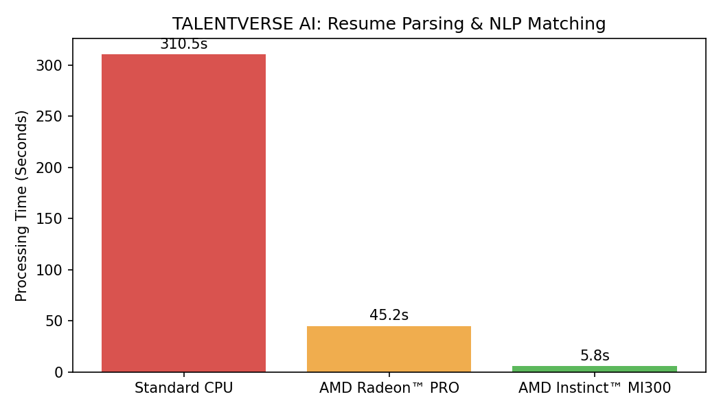
Figure 1: Processing Latency for 5,000 Resumes
Figure 1 demonstrates the crippling bottleneck of legacy hardware. The standard CPU server required over 5 minutes (310.5 seconds) to process the batch of resumes. Offloading this to a local AMD Radeon PRO reduced the wait to 45 seconds. Ultimately, deploying to the datacenter-grade AMD Instinct MI300 processed the entire candidate pool in just 5.8 seconds—an incredible 53x speedup.

5. Conclusion
The integration of AMD's ROCm compute ecosystem fundamentally shifts the capability of TALENTVERSE AI. By transforming a 5-minute background task into a 5-second interactive query via AMD Instinct acceleration, recruiters can now dynamically filter and match massive talent pools in real-time.

